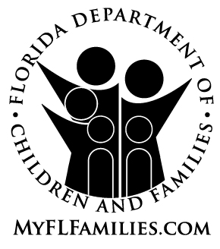 | ATTESTATION OF COMPLIANCE  Background Screening Requirements for Child Care Personnel

To be returned with the application or Child Care Licensing Questionnaire. Authority: s. 402.305(2)(a)-(b), F.S.
List all persons employed in the Child Care Facility. s. 435.05(3), F.S.
s. 435.04, F.S.

DESIGNATE EMPLOYEE BACKGROUND SCREENING STATUS AS:
Incomplete forms will be returned and C – CLEARED Clearance Letter on File
will delay the process. S – SUBMITTED Results Pending

 | Social |  | Date | (check one) |  | 5 Year
Name | Number  Security | Date  Hired | Screening Submitted | C | S | Re-Screening Date

I, |  | , Applicant of
Child Care Facility, do hereby attest under penalty of perjury that all child care personnel are in compliance with the provisions of Chapter 435, F.S.

______________________________________________ Date:___________________
Signature of Applicant

